**Tutorial on Radon Sensor Hacking **

**EECS397/EECS600, Mobile Computing&&Sensor Network, Fall 2015**

**Advisor: Prof. Ming-Chun Huang**

**Introduction:**

In this project, we will learn how to hack a radon sensor and how to connect the radon sensor to Edison with sensor board. Radon is a kind of ubiquitous, colorless, odorless, cancer-causing, radioactive gas which emanates naturally from the ground as well as from certain construction materials. Indoor radon measurement is useful in assessing health risks because the gas can be accumulated in basements, dwellings or working places and from there it can be inhaled by people populating these areas. In this tutorial, you will build a simple radon data recorder prototype. After you finish this prototype, the radon sensor data is saved into a .txt file in the SD card on the Edison board. In tutorial 3, you have built client-server communication between Edison broad and smart phone. In the end of this tutorial, you also should be able to send the txt file from Edison to smart phone via Bluetooth.

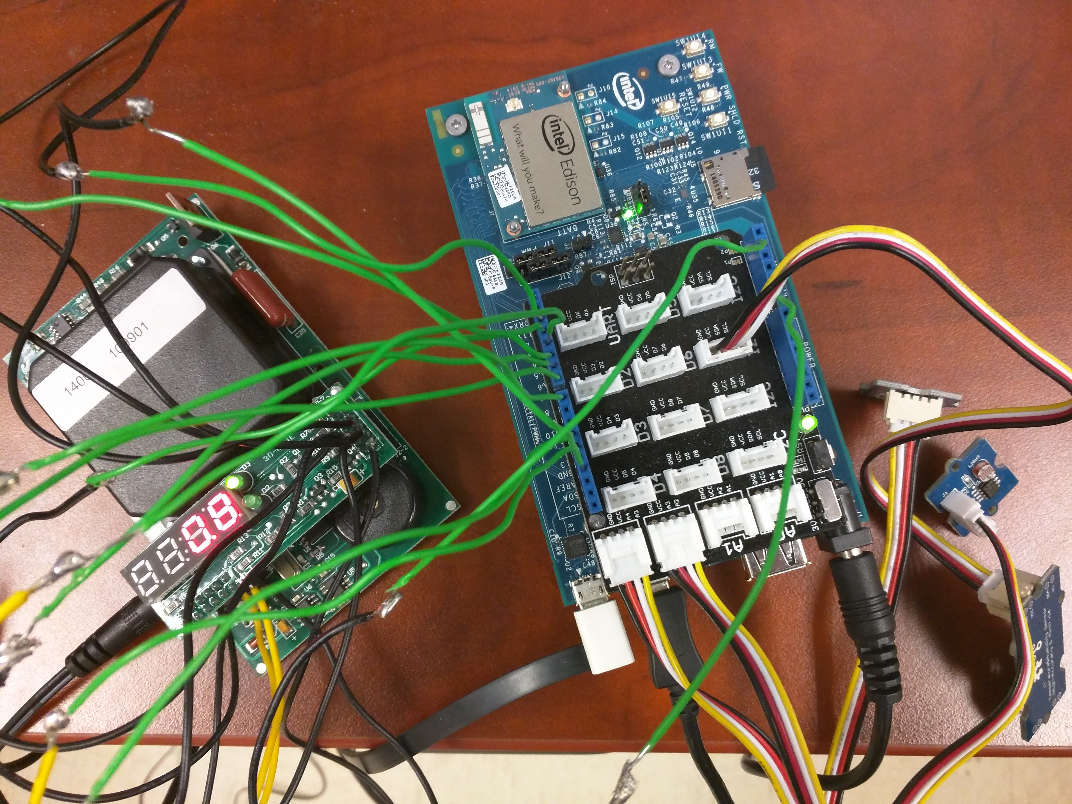

**Figure 1**

Figure 1 is an example of an Edison-Radon sensor data transmission system. You remove the cover and connect radon gas sensor with Edison board. In this system, you should be able to save the radon sensor data and on board sensor data to the SD card at the same time.

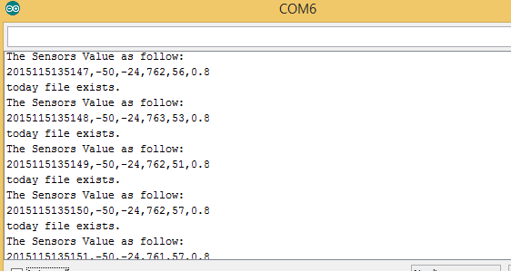

Figure 2-a

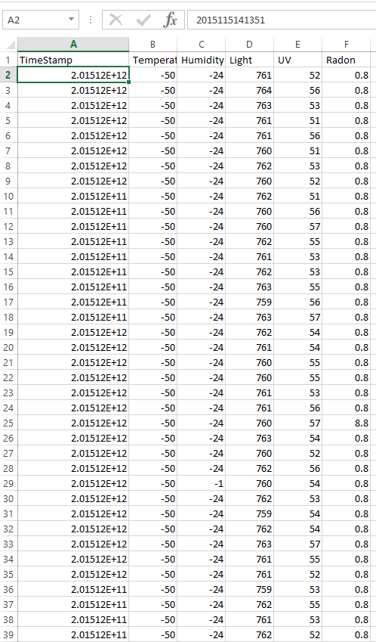

Figure 2-b

Figure 2-a show you the serial monitor display of hacking. Figure 2-b show you the example of CSV file received by the smart phone. You need use Edison to send txt file in SD card to the smart phone via Bluetooth. Android Client app in smart phone should save the received data in CSV file.

In this project, we assume that you know how to transmit data from Edison to smartphone (Lab 4) and know how to mark your home location on google map (Lab 3).

Disclaimer: This tutorial is for educational purpose only and it is not a 100% step by step tutorial, which means students still need to finish some parts by themselves. It is intended for students who would like to quickly overview the embedded system and Android development. Without considering security and reliability, according to this tutorial, students can build a fast-working prototype for their class project.

***Pre-requisite:***

1. EECS 132 and EECS 233

***Part I: Preliminary knowledge***

A seven-segment display (SSD), or seven-segment indicator, is a form of electronic display device for displaying decimal numerals that is an alternative to the more complex dot matrix displays. Each one of the seven LEDs in the display is given a positional segment with one of its connection pins being brought straight out of the rectangular plastic package. These individually LED pins are labelled from **A** through to **G** representing each individual LED.

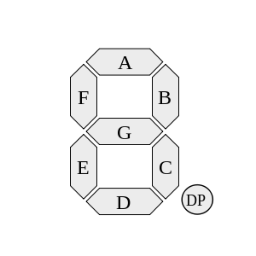

There are two types of LED 7-segment display called: **Common Cathode** (CC) and **Common Anode** (CA). In our tutorial, we use **common anode** display. In the common anode display, all the anode connections of the LED segments are joined together to logic “1”. The individual segments are illuminated by applying a ground, logic “0” or “LOW” signal via a suitable current limiting resistor to the Cathode of the particular segment (a-g).

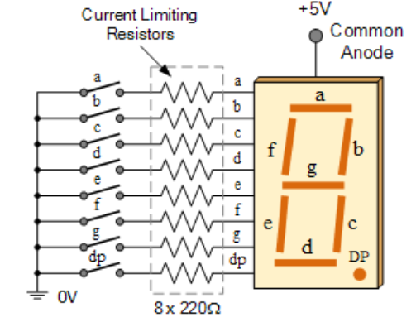

Hexadecimal digits can be displayed on seven-segment displays. Depending upon the hexadecimal digit to be displayed, the particular set of LEDs is forward biased.

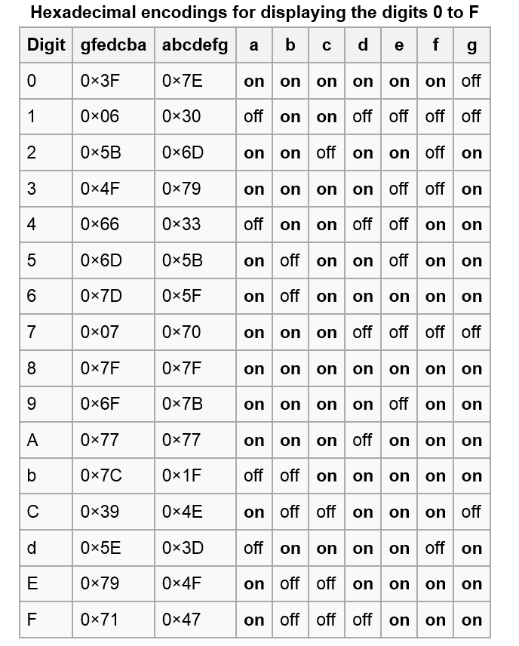

***Part II: Radon Sensor Hacking***

***Removal of cover***

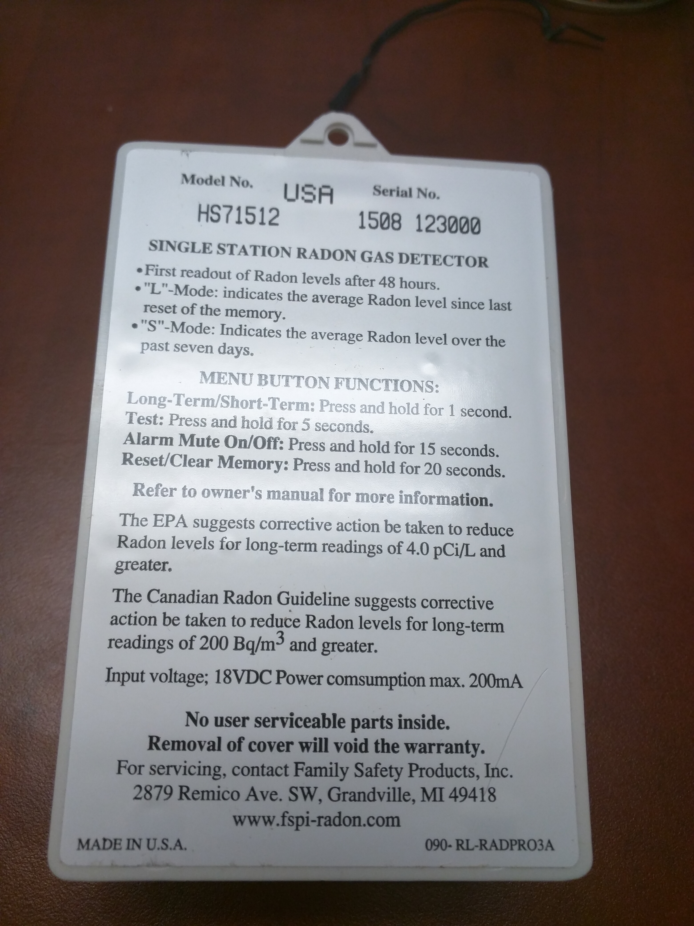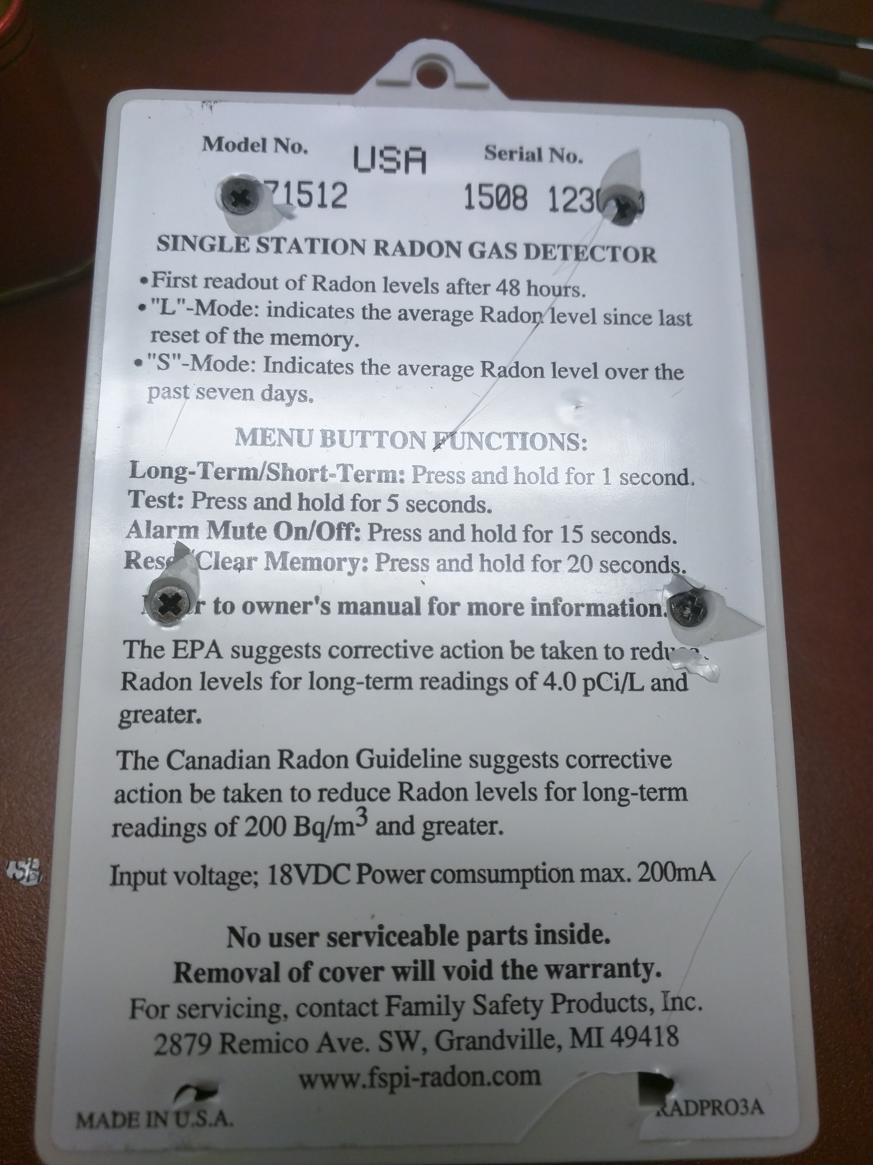

***Getting Started with Radon Gas Detector (Model No: HS71512)***

The display has four 7-segment LEDs and it reports in 0.1 pCi/L. The mode is displayed with two LEDs.

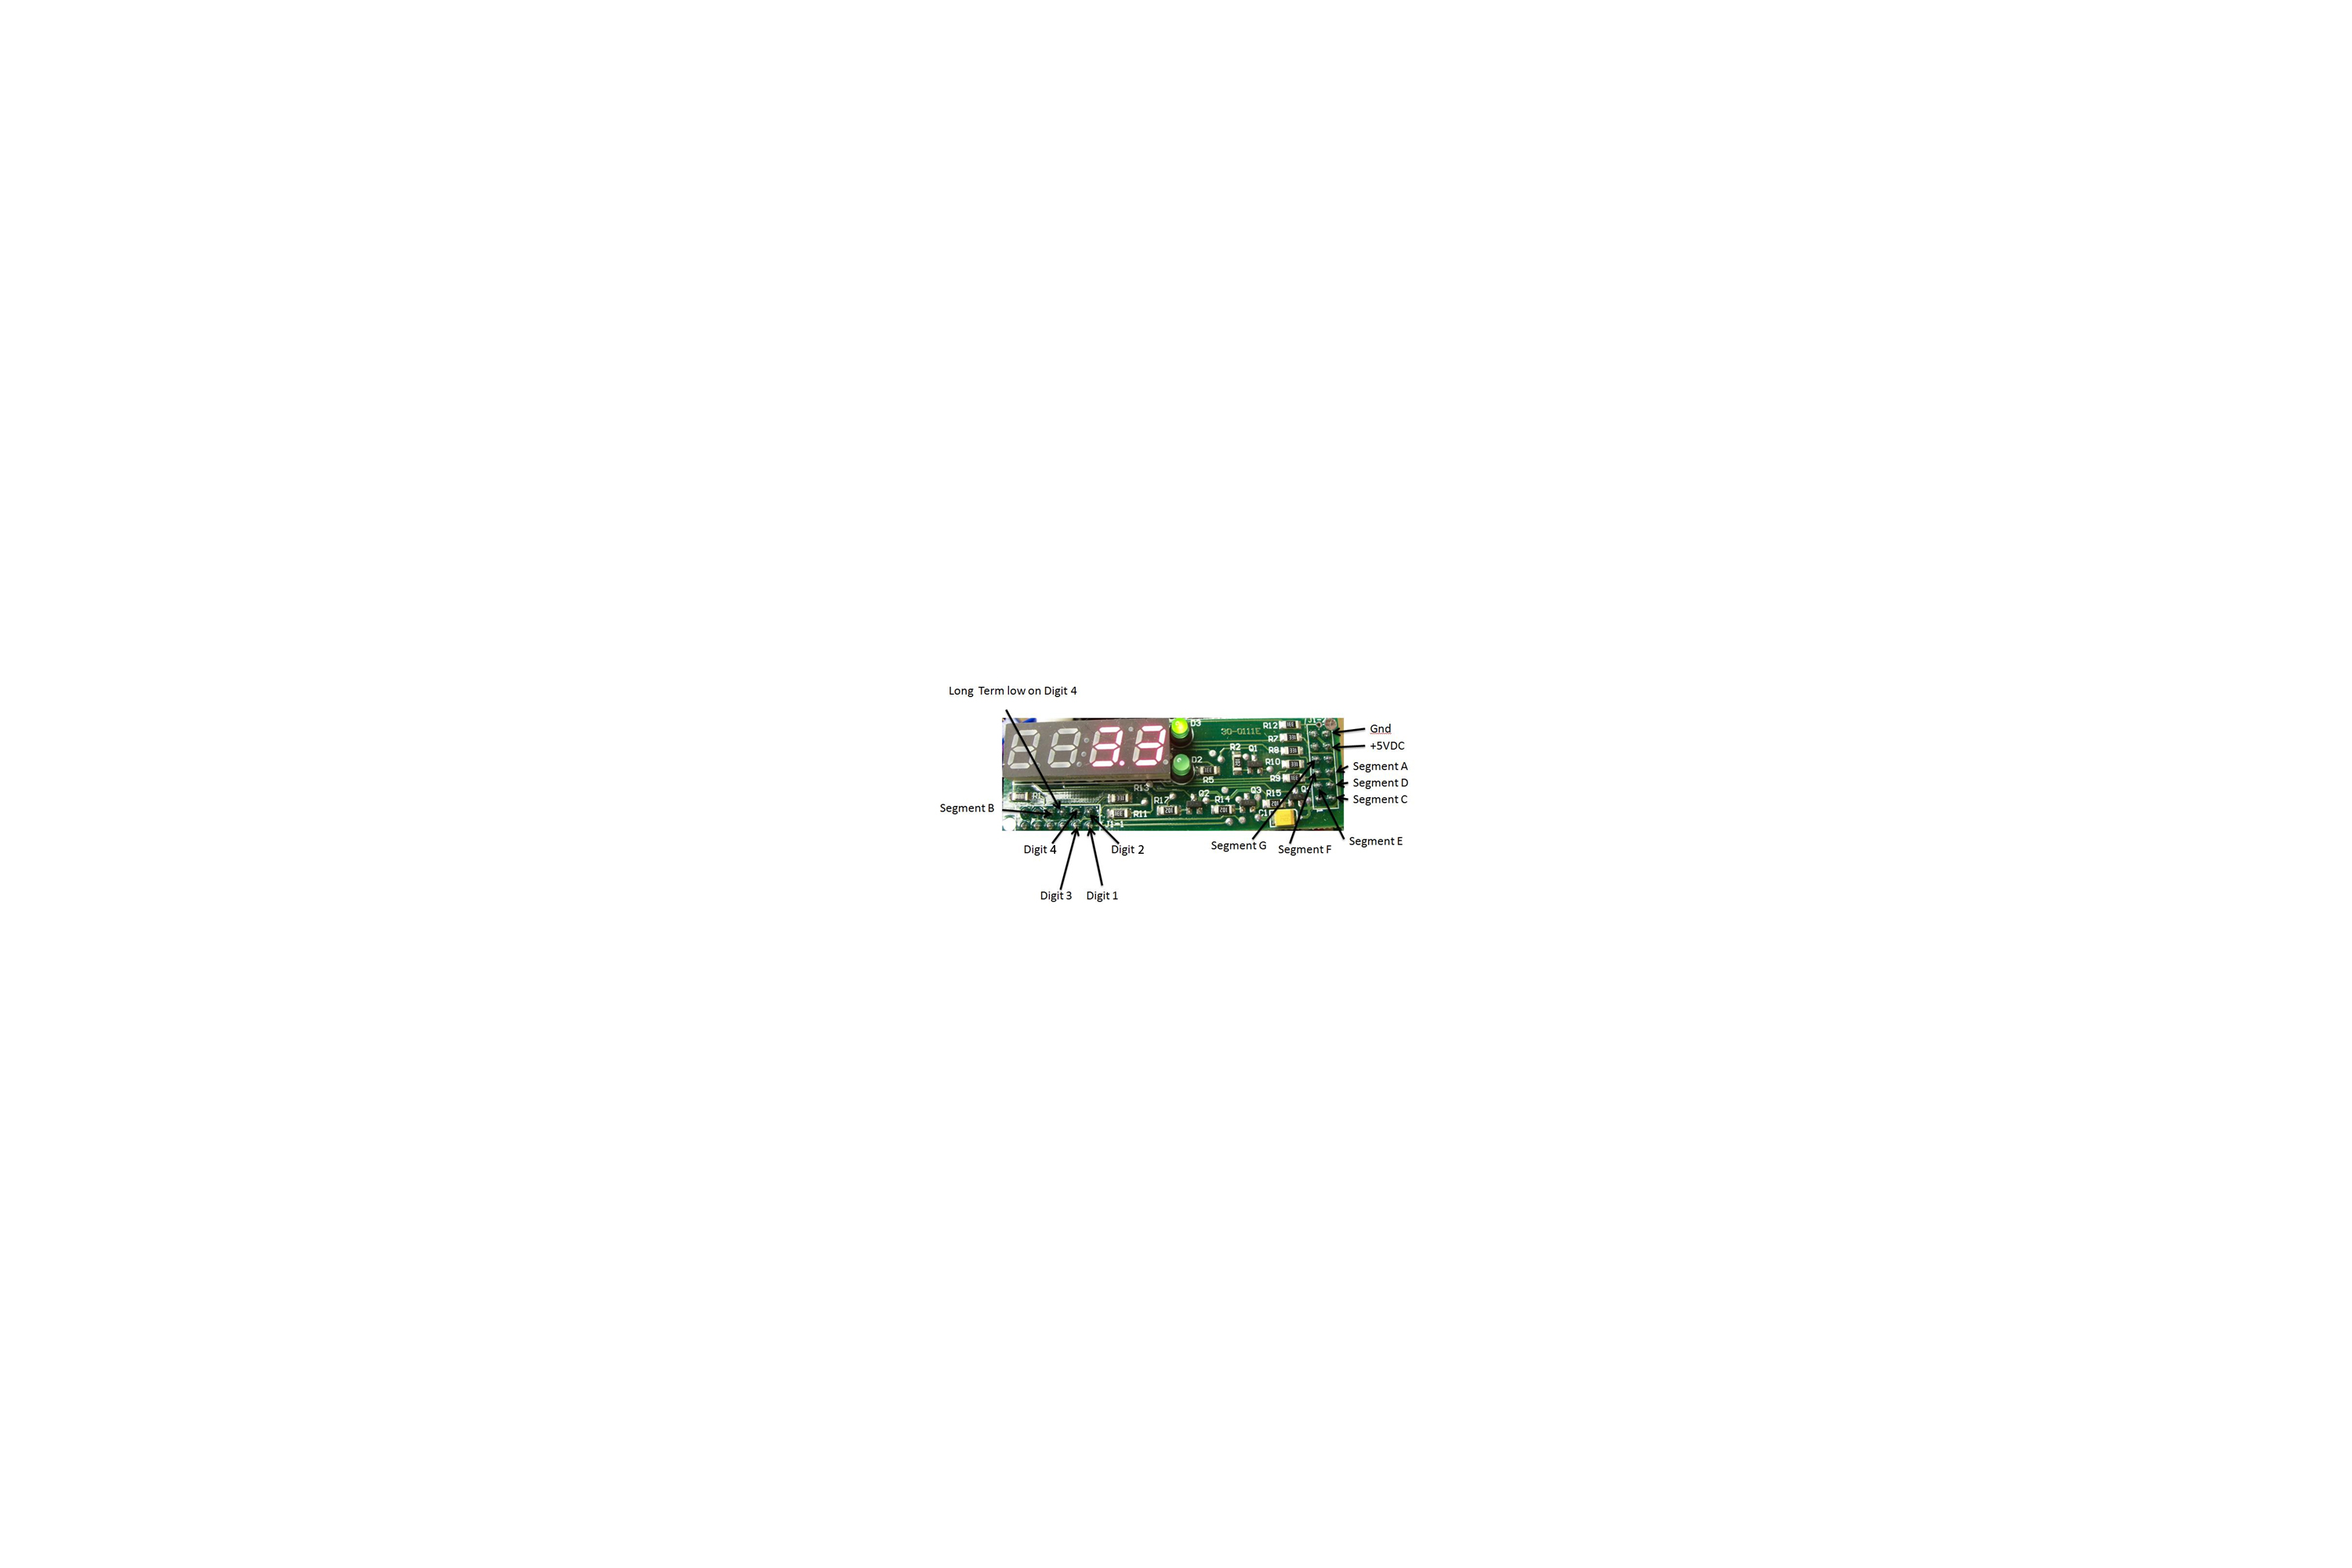

Figure 3

You can correspond each of segment and digit to the specific pin according to the figure 3, 4 and 5. In order to save the radon sensor data to the SD card on the Edison board, you need to connect radon gas sensor board with Edison board. Figure 4 is just for example.

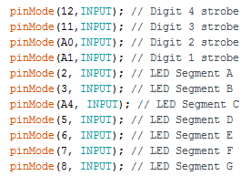

Figure 4

You may need some soldering work to build the whole prototype like figure 1. Please following the soldering iron safety instructions.

(1) Never touch the element or tip of the soldering iron. They are very hot (about 400°C) and will burn. (2) Hold wires to be heated with tweezers or clamps. (3) Keep the cleaning sponge wet during use. (4) Always return the soldering iron to its stand when not in use. Never put it down on your workbench. (5) Turn unit off or unplug it when not in use.

The following two figures show you the position of the required pins.

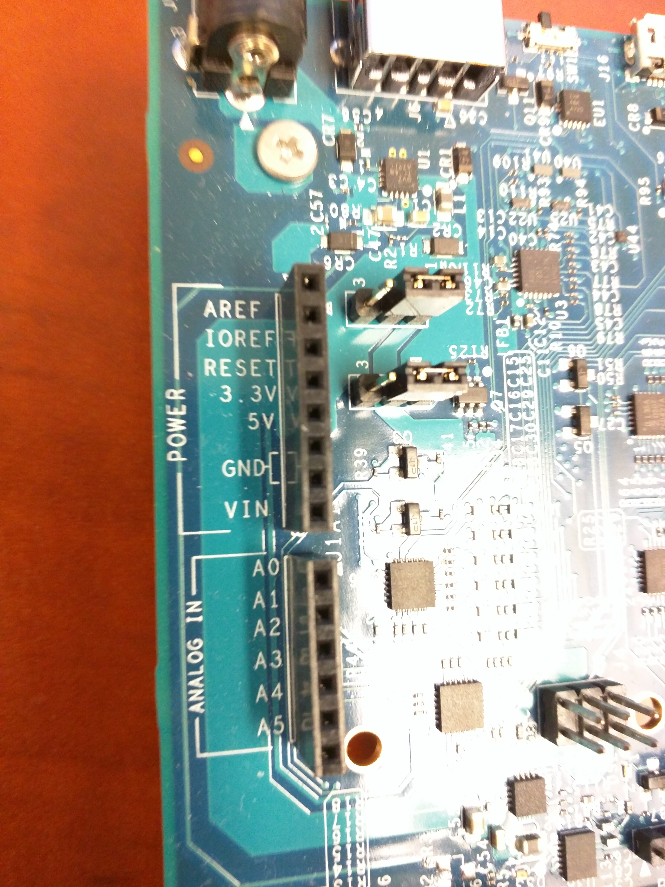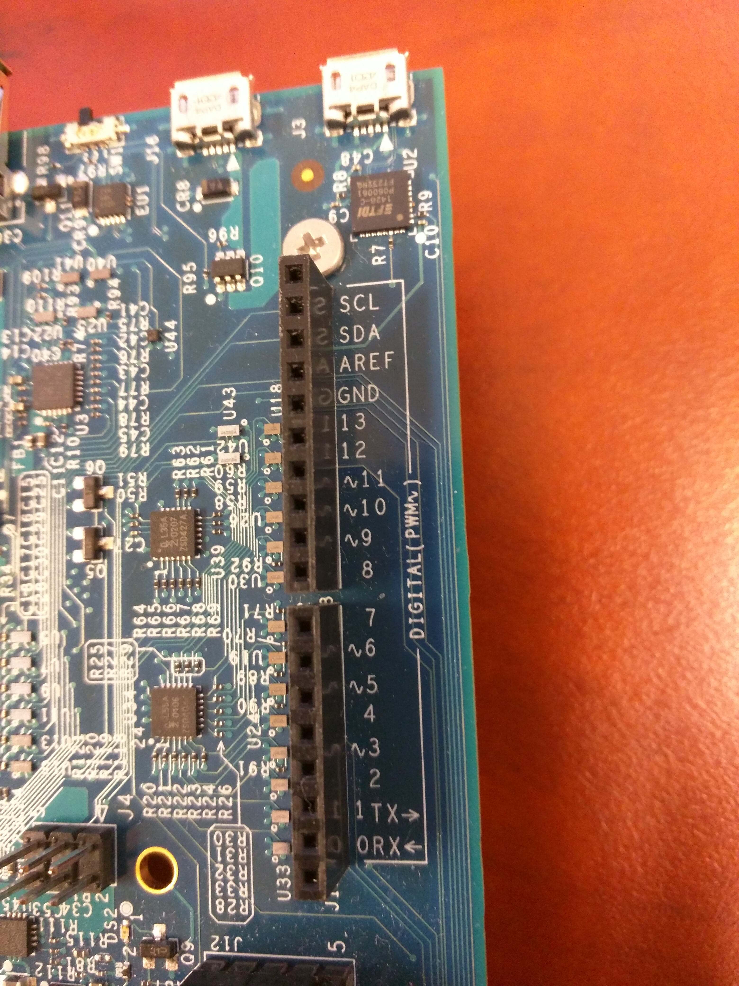

Figure 5

***Installing Arduino Libraries***

In order to access the timestamp, you need to import some external libraries. In this tutorial, we'll be using a fork of JeeLab's excellent RTC library RTClib - a library for getting and setting time from a DS1307. The uncompressed folder RTClib is in the zip file. Then, copy and install it in your Arduino directory.

Before you install the libraries, it would be a good idea to think about how you will organize your related libraries. One way that works for me is to have a folder that contains everything related to Arduino. That folder, which I’ve called ‘Galileo’ is at the top level in my personal area …\Haotian\Galileo\Sketch. Beneath Sketch I have a sub-folder called libraries which will eventually contain more sub-folders for the Arduino Libraries.

This is the structure:

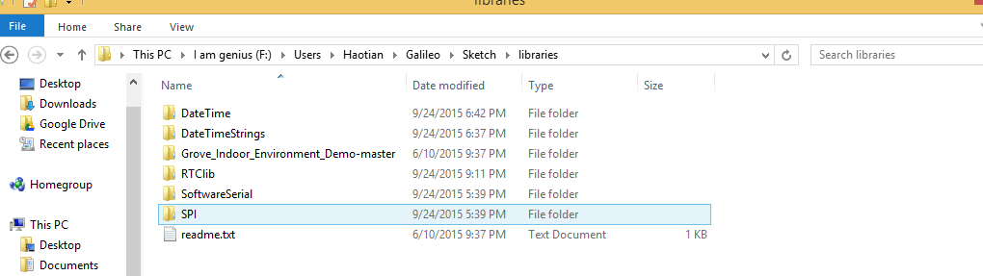

Then, you need let Arduino knows the location of the sketch folder. Open Arduino IDE 1.6.5, click File/Preferences, and set the preferences like the following figure.

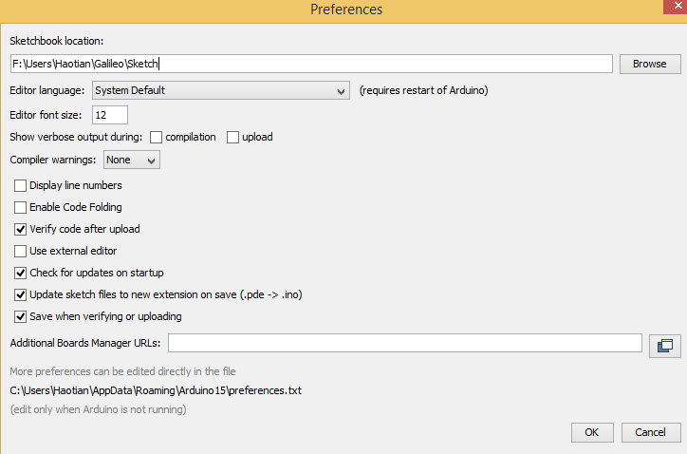

Then, you should be able to open the build-in example as following figure.

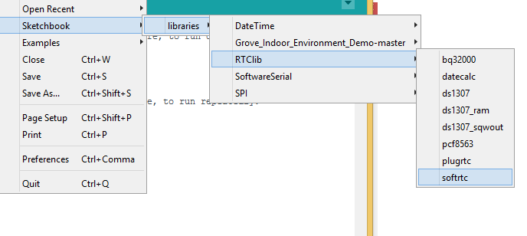

If everything is ok, you should be able to upload the “softrtc” example and run it successfully.

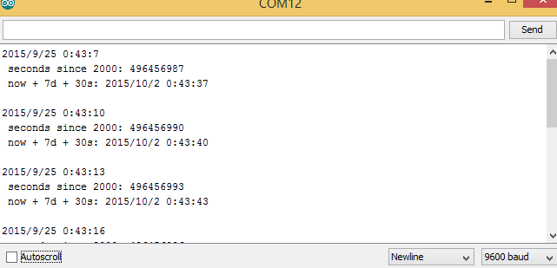

Note that: This is NOT the same “libraries” folder that is part of the Arduino IDE. If you put the contributed libraries in there, they will also work but when you update the Arduino IDE, by default it installs in a completely new folder and you will have to move or copy these libraries again and again. For that reason it is not recommended.

Now, you have learned how to install the Arduino libraries and how to use RTClib to get timestamp. Let’s go to the next topic.

***Arduino Programming***

There is a txt file in the zip file. This is the Arduino 1.0 Sample code for Safe Siren Radon Gas Detector Model HS80002. It shows how it is relatively easy to create text with the radon value. You have to modify this sample code so that you can achieve the desired function shown in figure 1 and 2.

**Requirement:** After you finish the Arduino code (accessing the radon sensor data and on board sensor data), you can upload the code to Edison and run it. Keep the arduino code running in the Edison, you can invoke the python code using PUTTY, which means the python code and Arduino code are running at the same time. In this way, you can transfer the sensor data from SD card to smart phone via Bluetooth, while keep collecting the new sensor data.

Homework 1: Please hack the radon sensor (Model No: HS71512), and read the sensor data using Edison. Then, try to save the sensor data to a txt file on the SD card.

Homework 2: Up to now, you have stored the radon sensor data (txt file) on the SD card on the Edison board. In assignment 4, you learned how to send sensor data from the Edison board to a smart phone. Please take that function, and add it to this project. Please refer to **Figure 2-a and 2-b**, you should collect “temperature”, “humidity”, “light”, “UV”, “Radon” sensor data at the same time. The system overview is like **Figure 1**. The first column is timestamp. You should save these sensor data to a txt file in SD card first. Then, you should be able to send the content of the txt file to smart phone. The smart phone should save these sensor data to a CSV file.

Tip: Combine the Grove_Indoor_Development_demo with homework 1.

Requirement of homework 2:

1. When you keep running your Arduino code for several days, once pass the 00:00 am (For example, 20151101 >>>20151102), a new txt file name 20151102.txt should be created in the SD card automatically. Then, the incoming sensor data after 00:00 am should be stored in 20151102.txt instead of 20151101.txt.

2. Both CSV file format in smart phone and txt file format in SD card should be like,

|  |  |  |  |  |  |
| --- | --- | --- | --- | --- | --- |
| Timestamp | Temperature | Humidity | Light | UV | Radon |
| 201511011023 | … | … | … | … | … |
| 201511011024 | … | … | … | … | … |
| … | … | … | … | … | … |

3. The python source code will be given to you directly. The logic of the python code is that,

We assume that today is 20151105, and you have been collecting data for 5 days since 20151101. Now, you want to get the sensor data from 20151102 to 20151104. There are 20151101.txt, 20151102.txt, 20151103.txt, 20151104.txt, 20151105.txt in the SD card. The only thing you need to do is send “20151102” to Edison.

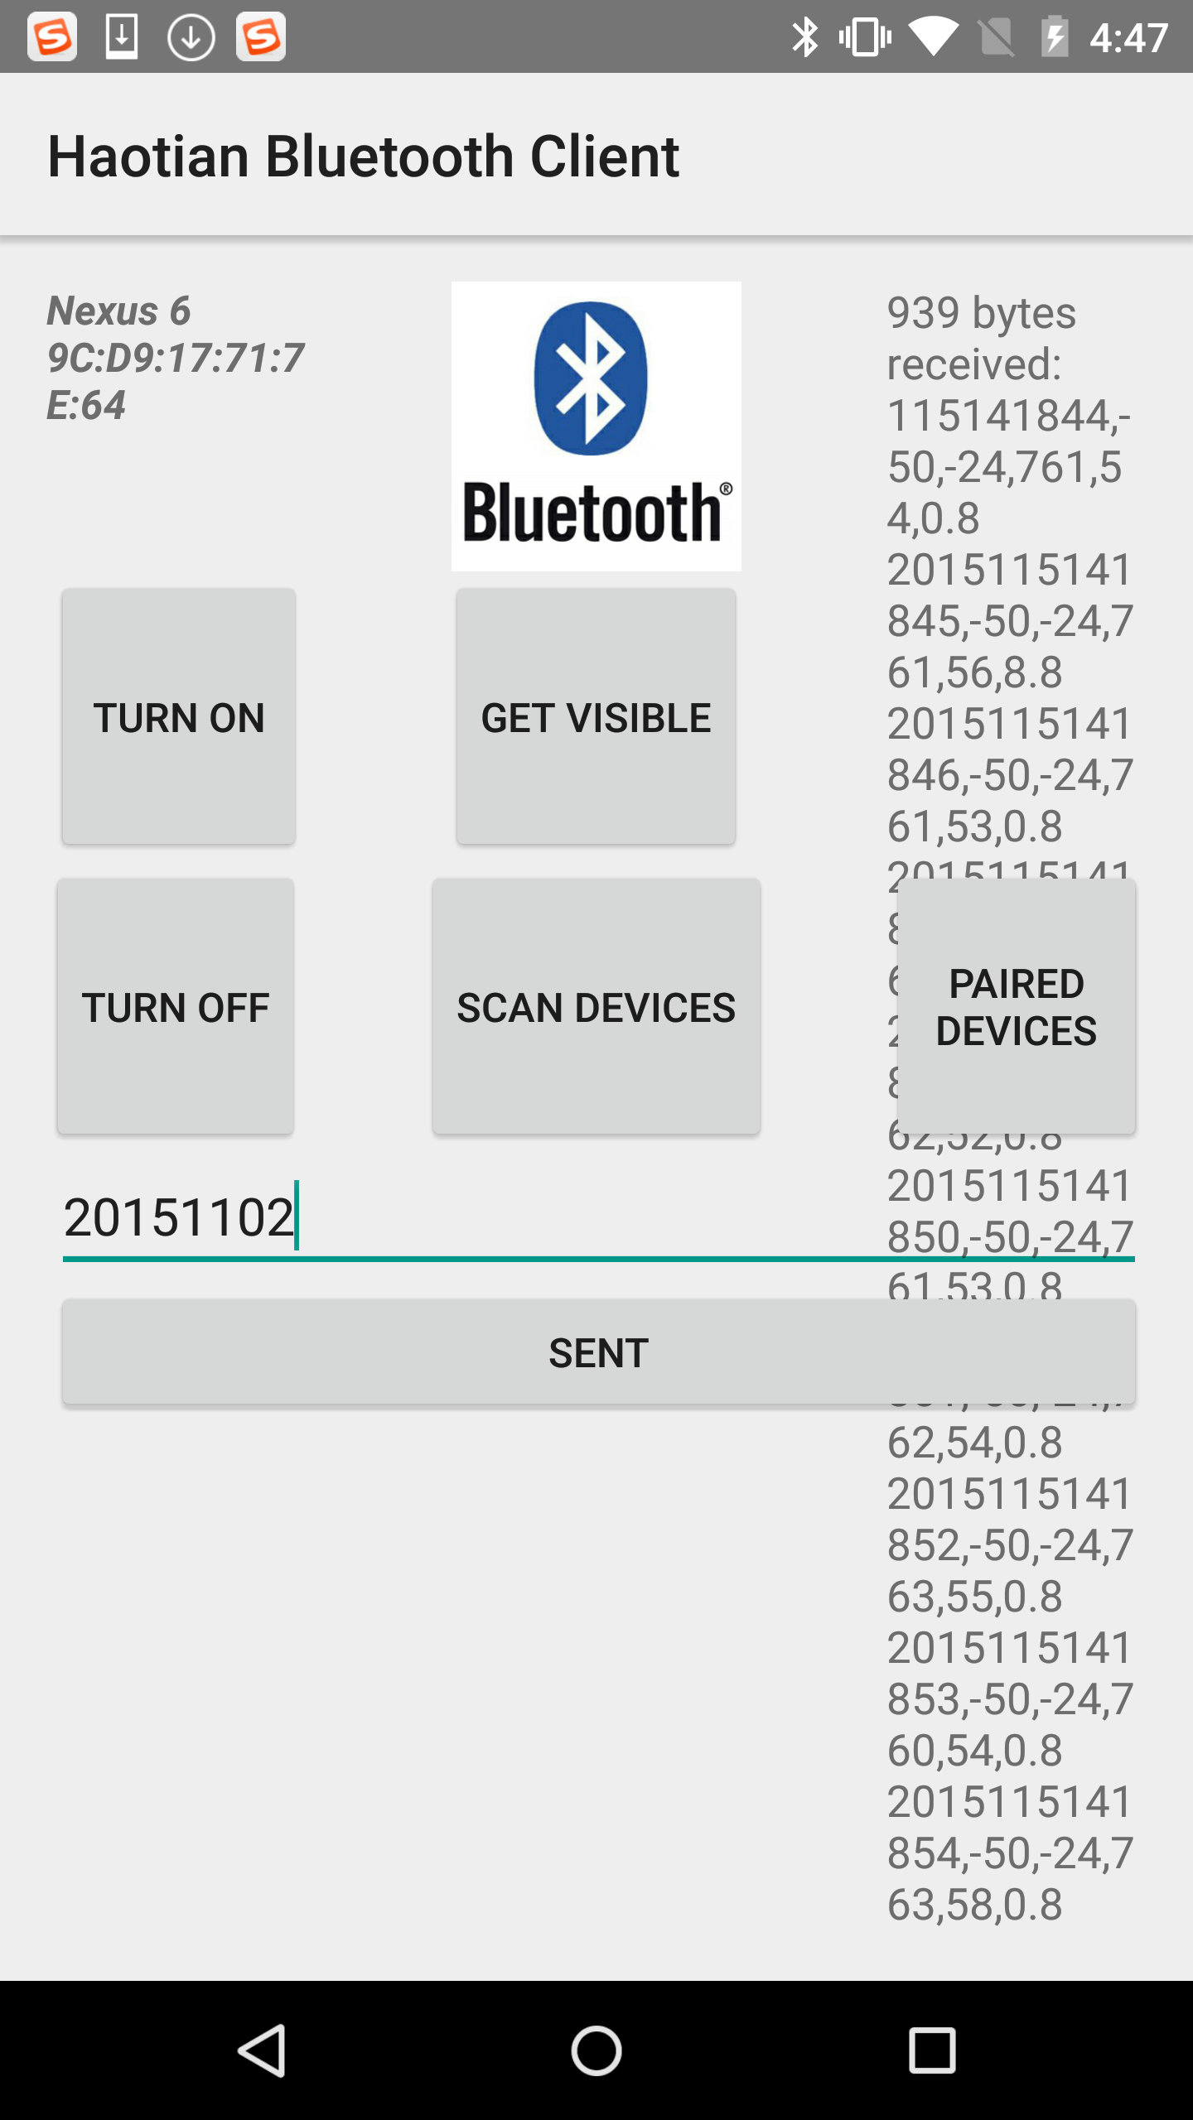

Then, Edison will automatically send the sensor data from 20151102 to 20151104 to smart phone via Bluetooth. The Bluetooth client on smart phone will save all these sensor data in one big CSV file (Figure 2-b).

Homework 3: Please keep collecting all of these sensor data from now, until the final project due date. You should alternate between collecting data from your living room and your partner’s living room, exchanging the board every couple of days, just like a cycle. **Switch the place for every two days**.

In assignment 3, you can get GPS data and mark your home location on the Google map. Please add the GPS data as one of the sensor data in the last column.

Requirement of homework 3:

1. Please add the GPS data as one of the sensor data in the last column.

|  |  |  |  |  |  |  |  |  |  |  |  |  |
| --- | --- | --- | --- | --- | --- | --- | --- | --- | --- | --- | --- | --- |
| Timestamp | Temperature | Humidity | Light | UV | Radon | Home Location |  |  |  |  |  |  |
| 201511011023 | … | … | … | … | … | (Long, Lati) |  |  |  |  |  |  |
| 201511011024 | … | … | … | … | … | … |  |  |  |  |  |  |
| … | … | … | … | … | … | … |  |  |  |  |  |  |

2. In the end, for example, you have 20 days to collect data, you should submit 10 CSV files. 5 files are generated in your home, and 5 files are generated in your partner’s home.

Submission:

1. Please take a video and in the video you should show us the demo about the whole process of homework2. You also should show the CSV file in the video.

2. Submit all your source code and CSV files and txt files, in well format and different folder.

3. Write a short report and tell us what your contribution is and your partner. **Video is much more important than report.**